**PROJECT REPORT TEMPLATE**

**1. INTRODUCTION**

**1.1 Overview**

Economic freedom is the fundamental right of every human to control his or her own labour and property. In an economically free society, individuals are free to work, produce, consume, and invest in any way they please. In economically free societies, governments allow labour, capital, and goods to move freely, and refrain and coercion or constraint of liberty beyond the extent necessary to protect and maintain liberty itself.

The index of Economic freedom is an annual index and ranking created in 1995 by the Heritage Foundation and The Wall Street Journal to measure the degree of economic freedom in the world’s nation. It is based on the Tax rates, Degree of juridical independence, Inflation rates, Cost of importing, and regulated prices.

Economic freedom has been shown to correlate strongly with higher average income per person, higher income of the poorest 10% higher life expectancy, higher literacy, lower infant mortality, higher access to water resources and less corruption. The share of income in percent going to the poorest 10% is the same for both more less economically free countries.

**1.2 Purpose**

The Index of economic freedom *compares the jurisdictions against each other for various aspects, such as trade freedom, judicial effectiveness, and tax burden.* These factors maybe weighted for their influence on economic freedom and collated into a single score for ranking.

**2. DEFINE PROBLEM / PROBLEM UNDERSTANDING**

**2.1 Empathy Map**

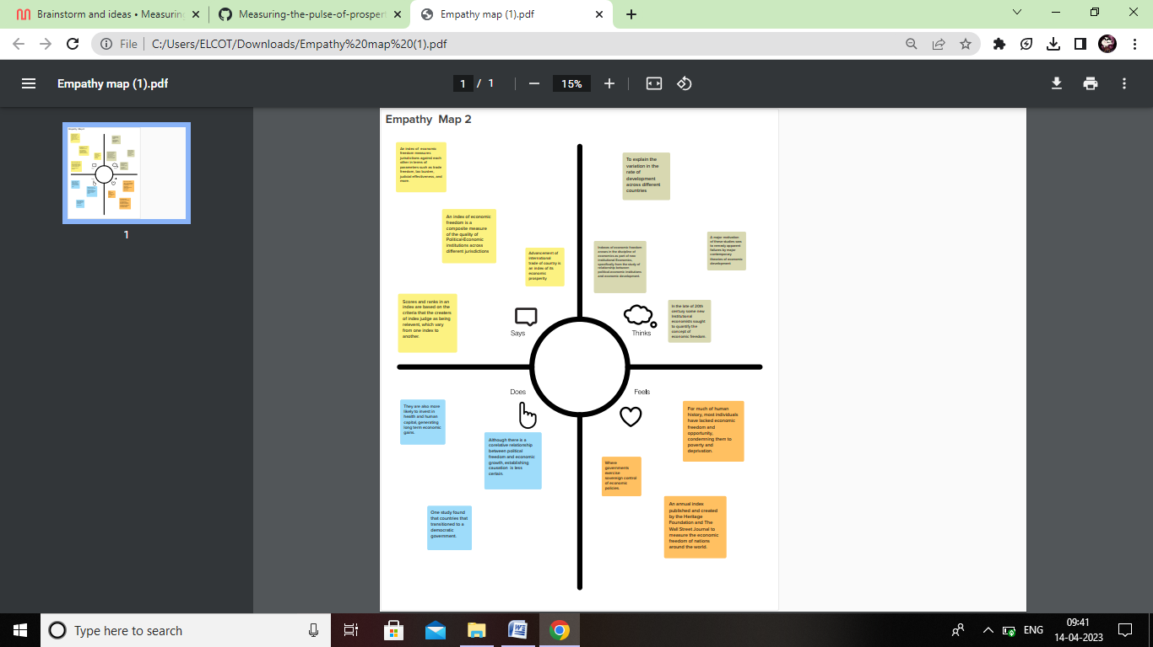

**2.2 Brainstorming and Ideation Map**

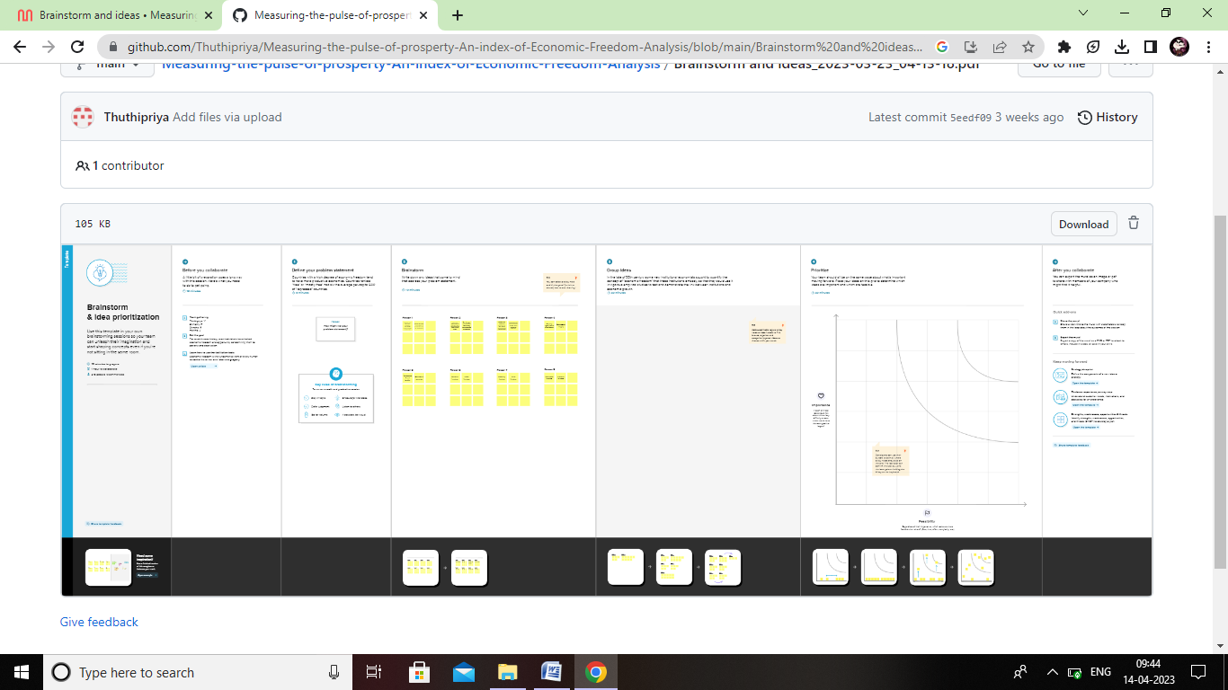

**3. DATA COLLECTION & EXTRZCTION FROM DATABASE**

**3.1 Collect the dataset & understand the data**

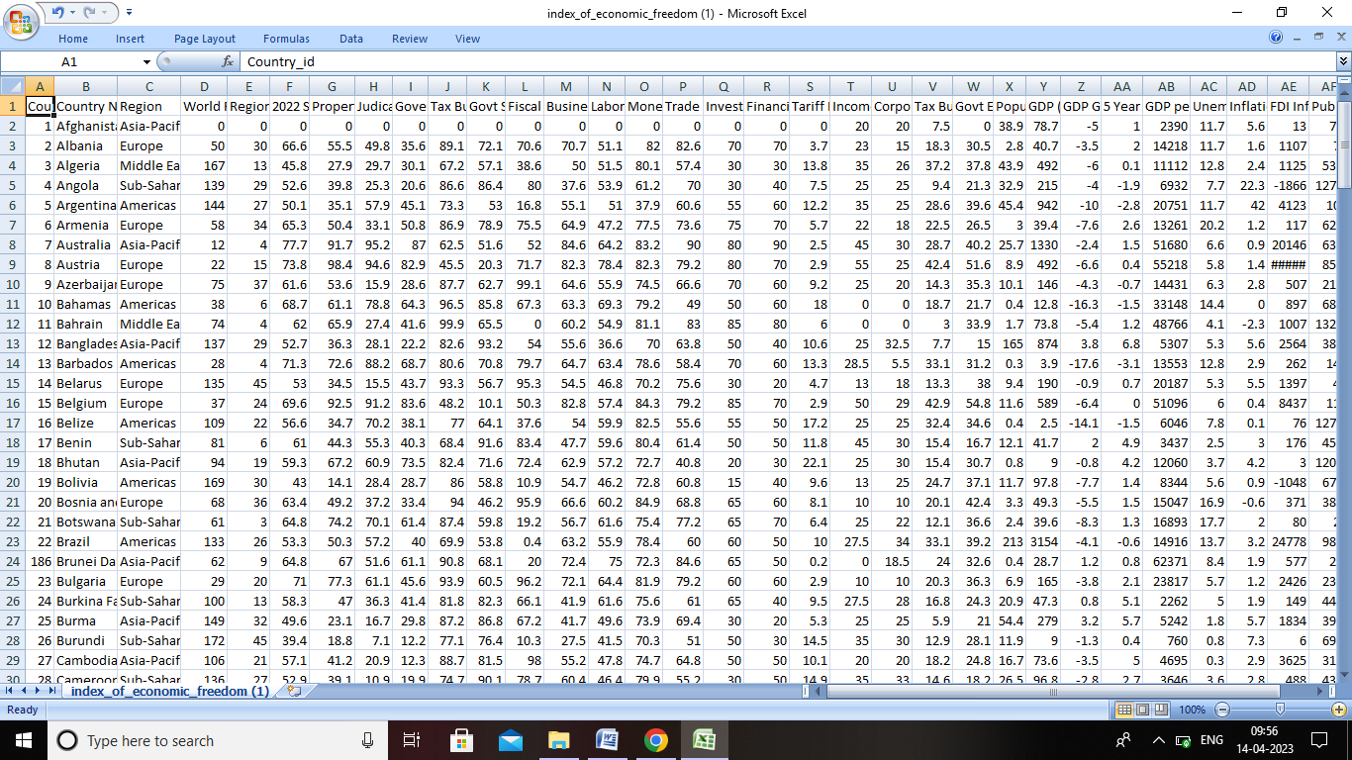

**3.2 Connect TB with Tableau**

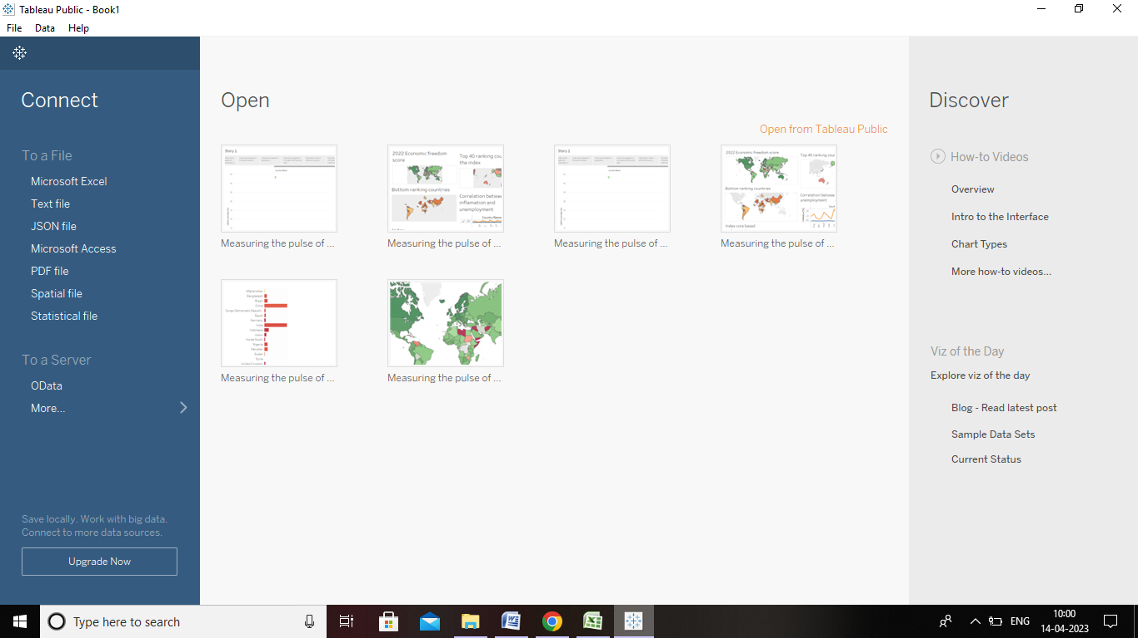

**4. DATA VISUALIZATION**

**No of unique visualization**

**4.1 2022 Economic freedom score**

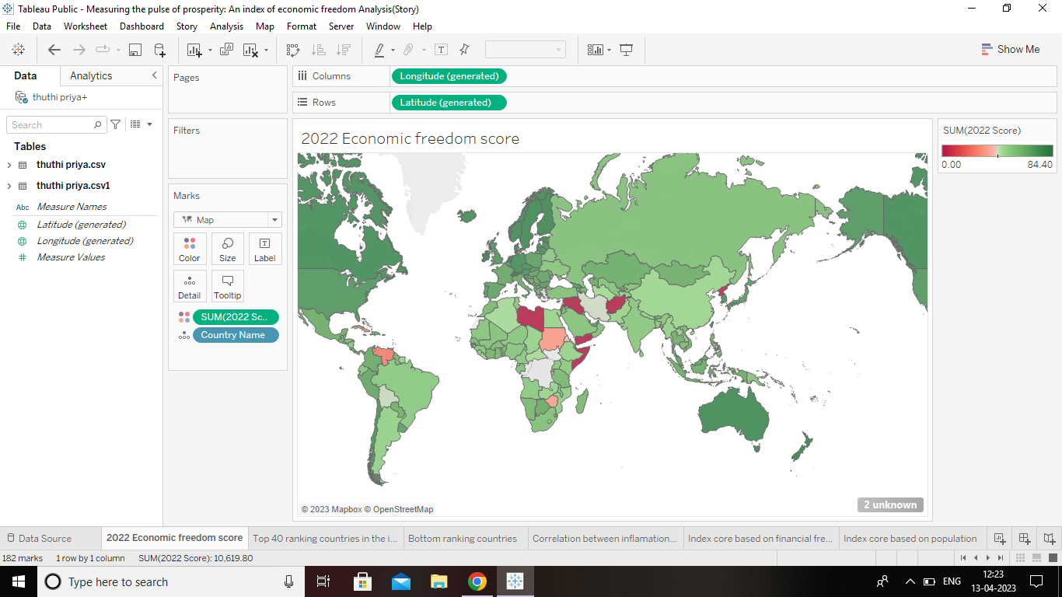

**4.2 Top 40 ranking countries in the index**

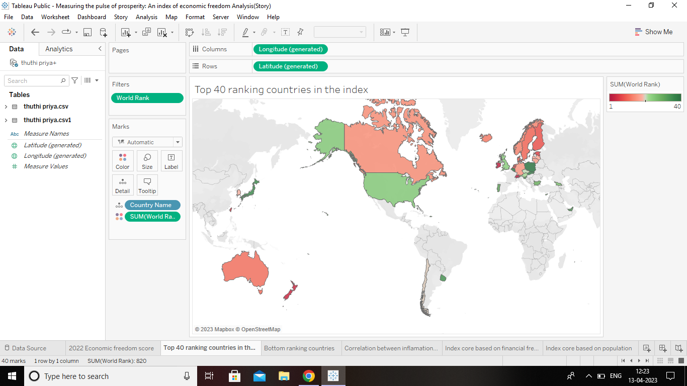

**4.3 Bottom ranking countries by index**

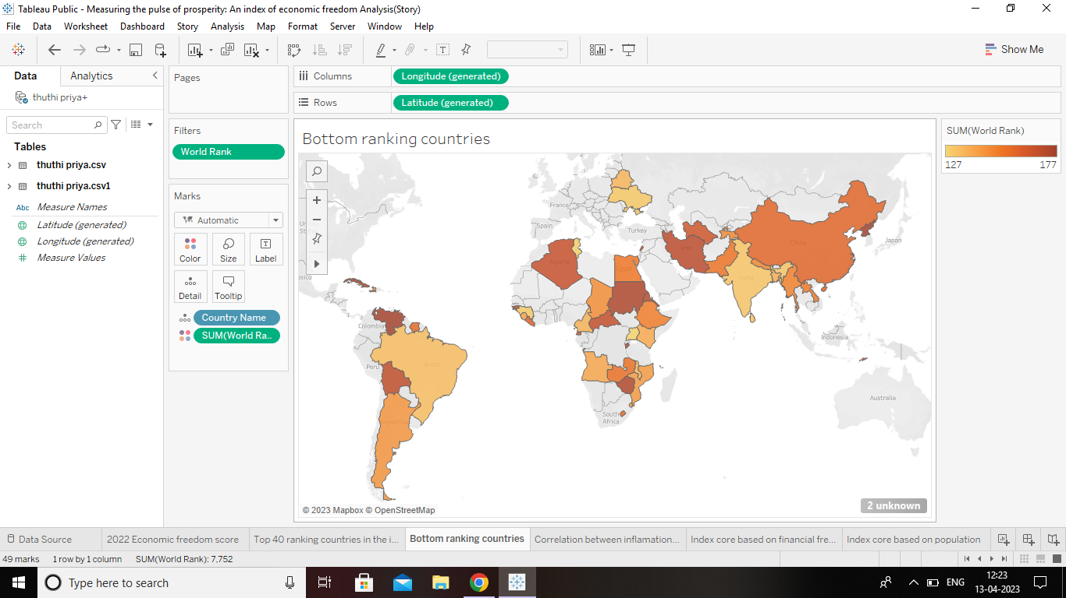

**4.4 Index core based on unemployment rate**

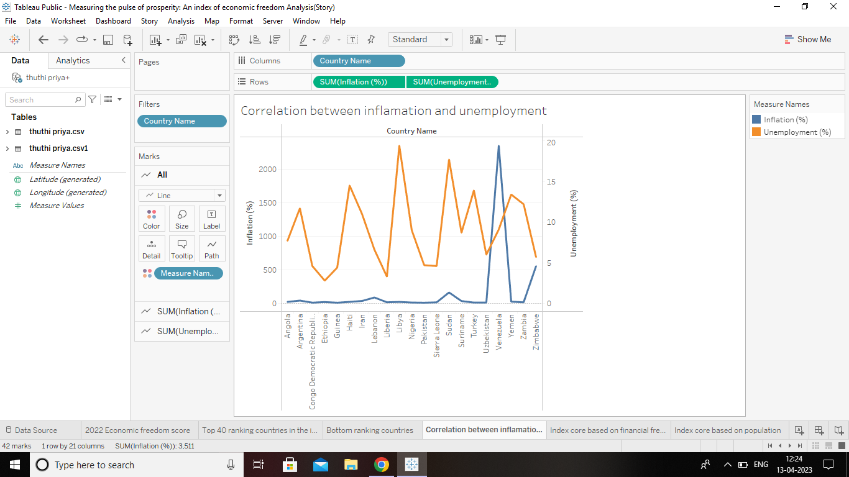

**4.5 Index core based on financial freedom**

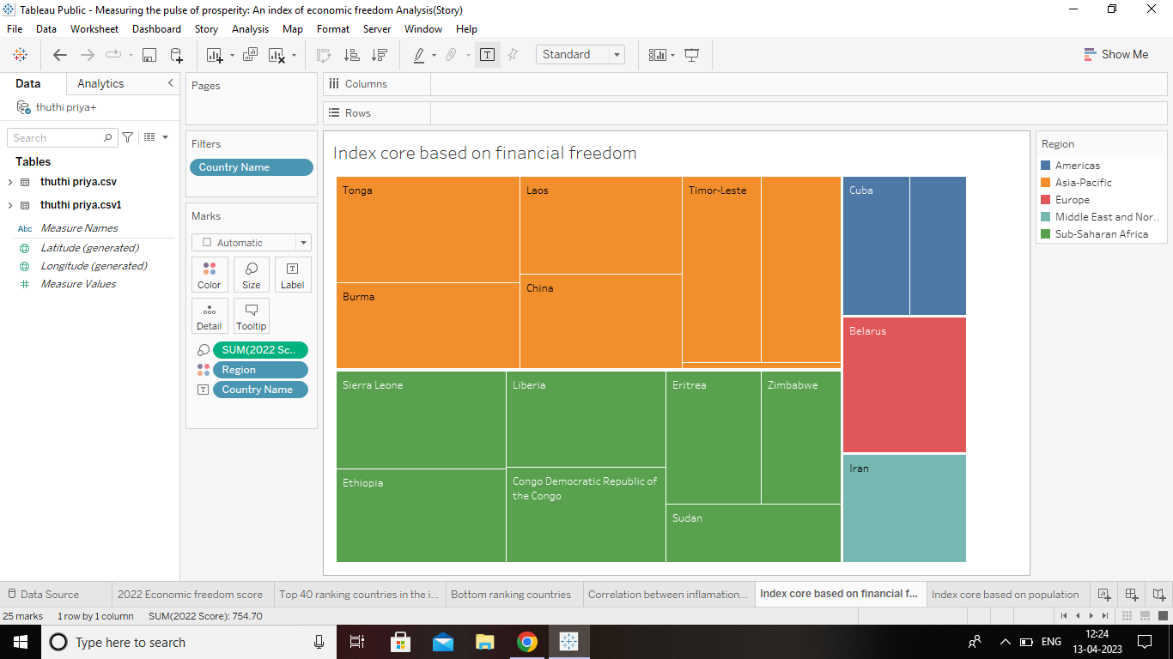

**4.6 Index core based on population**

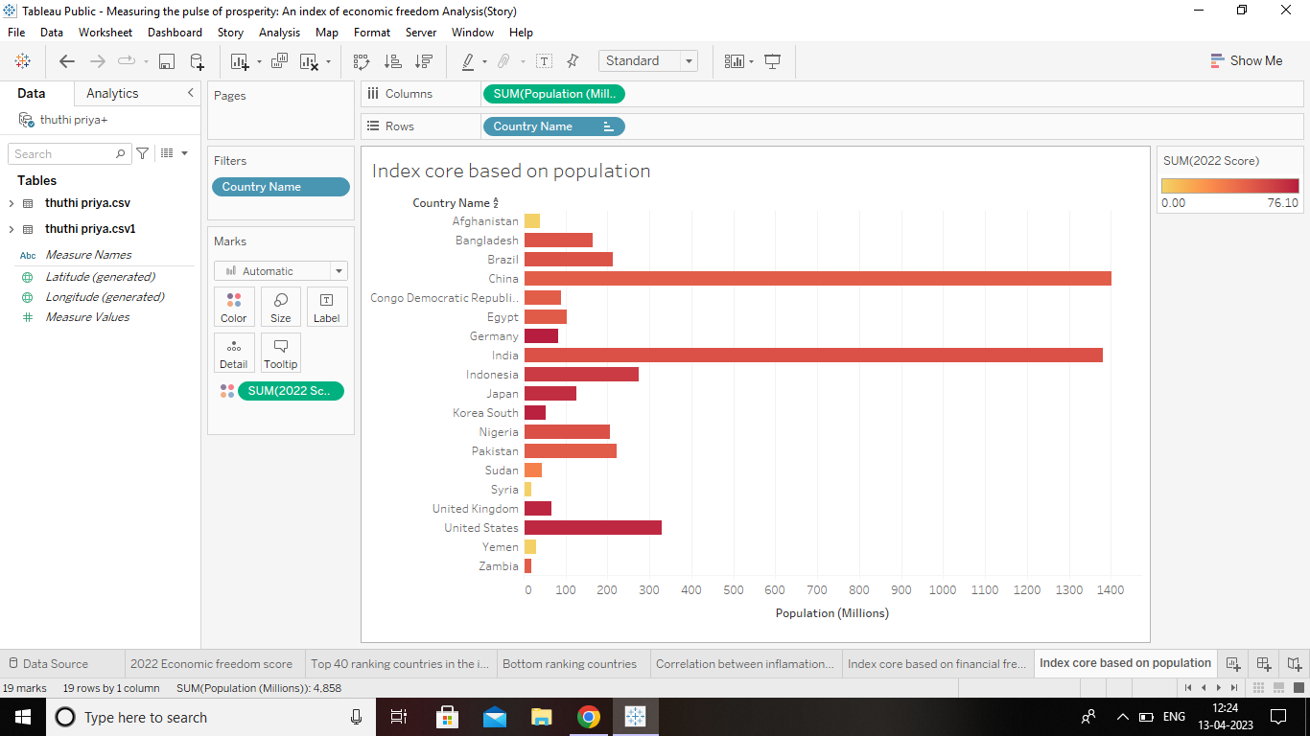

**4.7 Index core based on 5 year GDP growth rate (%)**

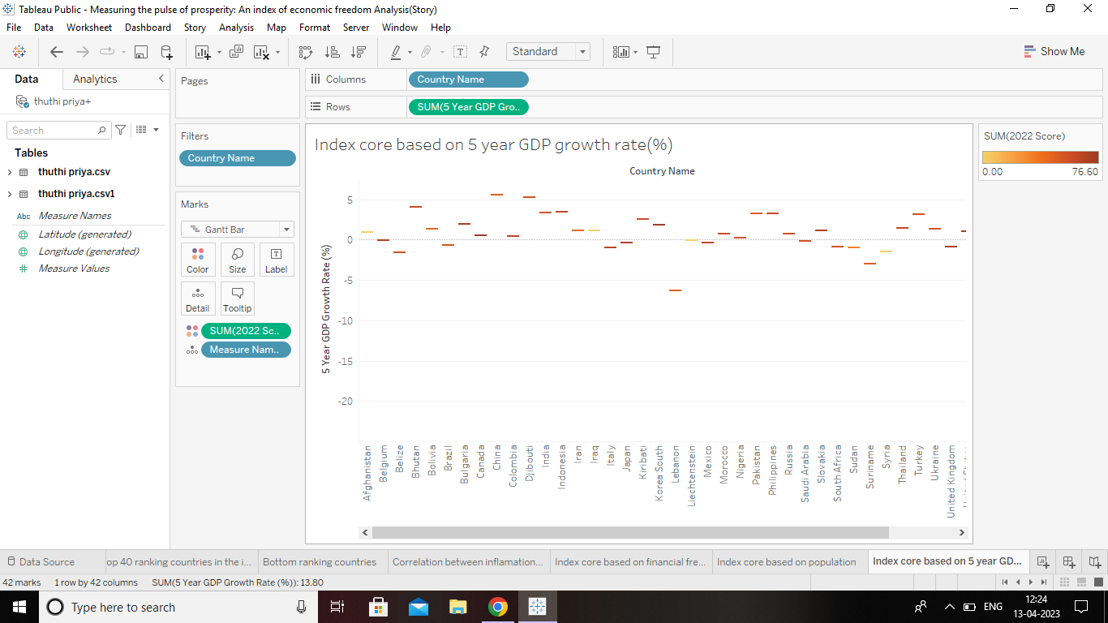

**4.8 Inflation rate in different countries**

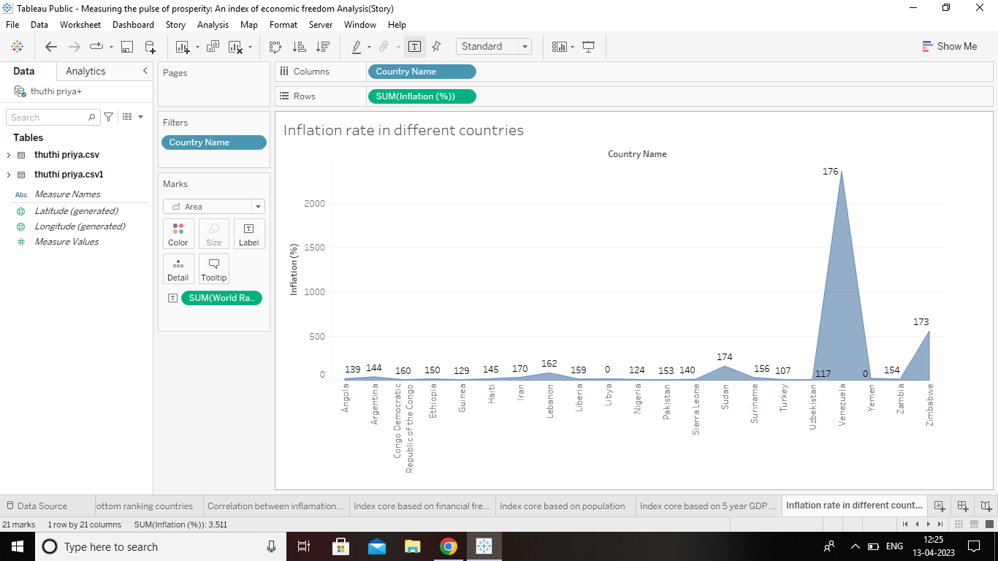

**4.9 Correlation between GDP(PPP) & Monetary Freedom**

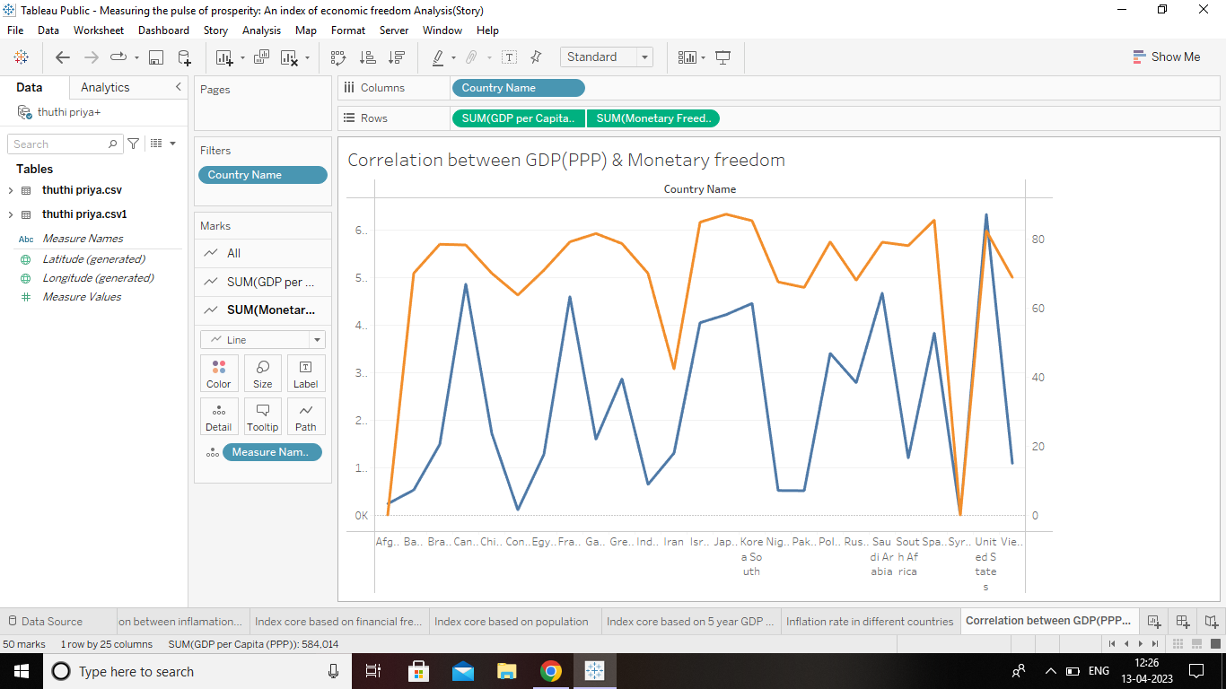

**4.10 Top 40 countries by GDP growth rate**

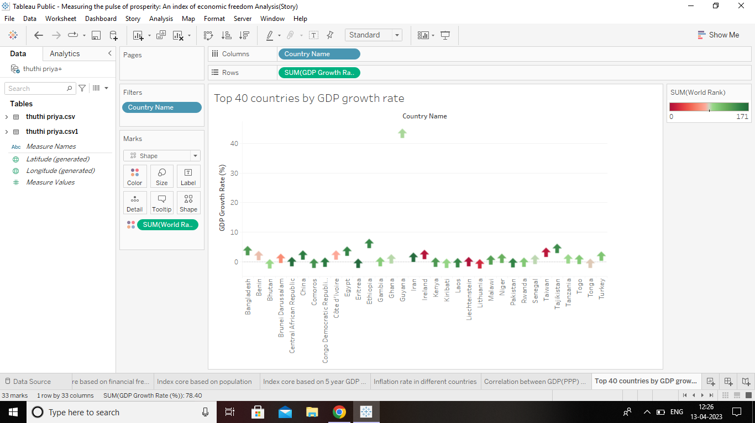

**5. DASHBOARD**

**5.1 Design of dashboard (1)**

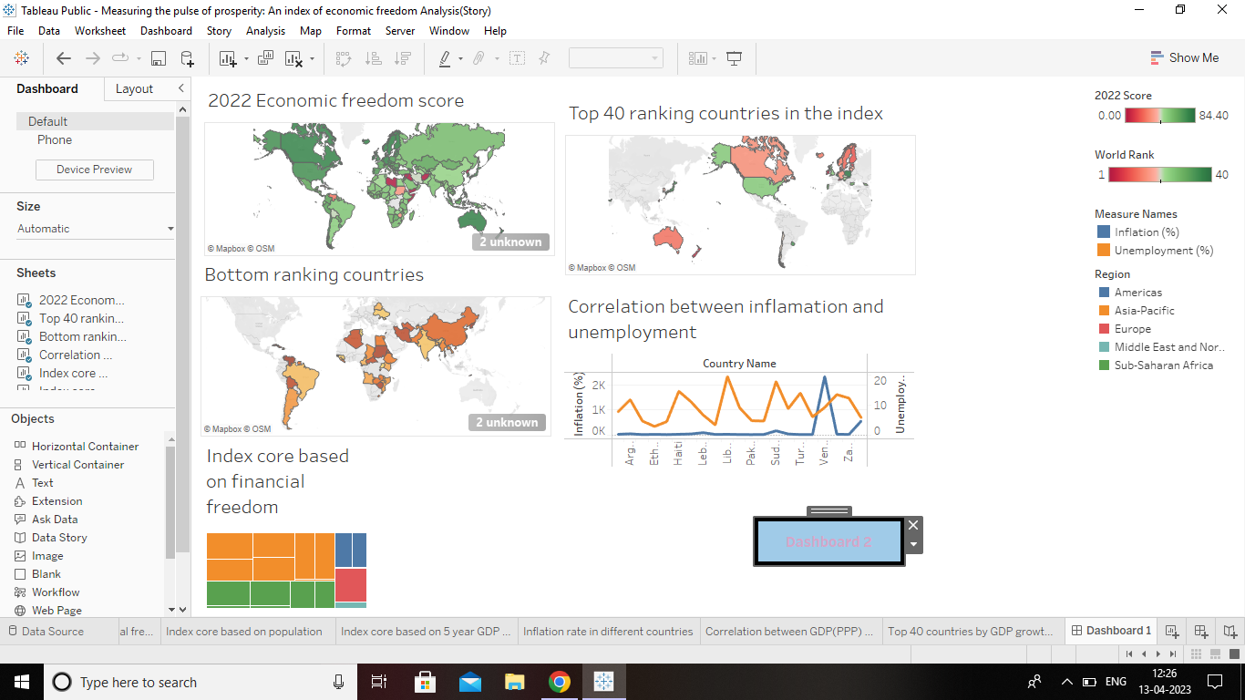

**5.2 Design of dashboard (2)**

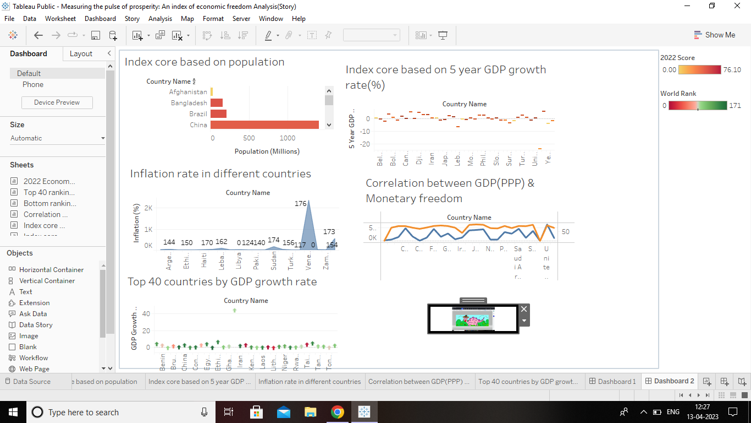

**6. STORY**

**6.1 No of scenes of story**

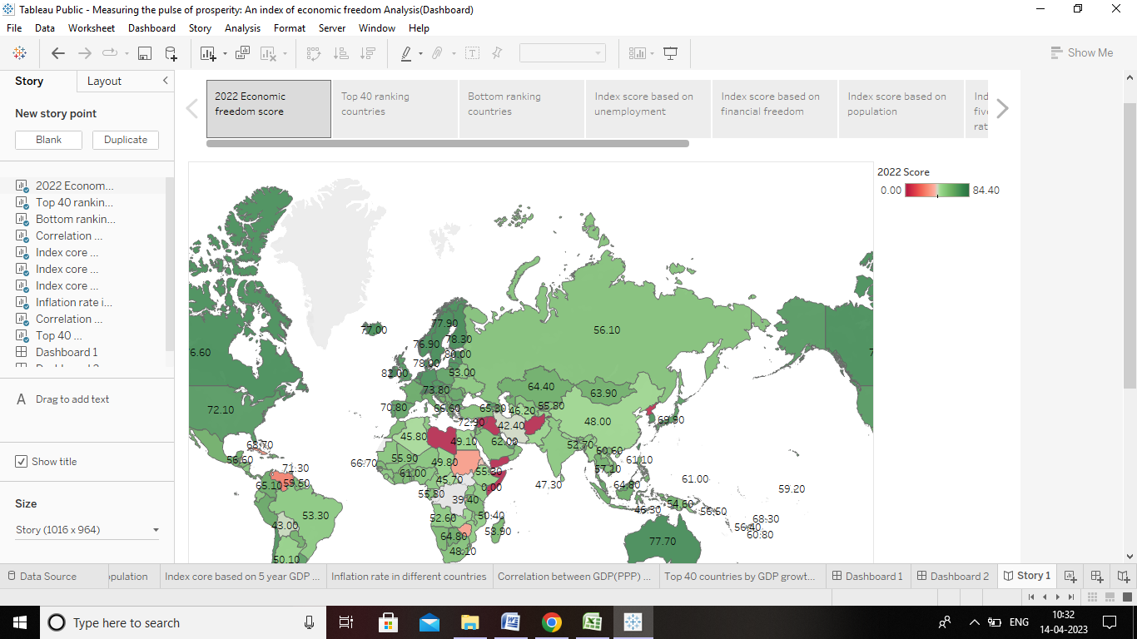

**7. ADVANTAGES**

**»** The most obvious benefit of economic freedom is that, as a system, *it is the most conductive to widespread prosperity*, that is, to high or rising income and consumption for the bulk of the population.

**»** The benefits of a market economy include *increased efficiency, production, and innovation.*

**»** Economic growth creates *higher tax revenues, and there is less need to spend money* on unemployment.

**»** Therefore economic growth helps to reduce government borrowing. Economic growth also plays a role in reducing debt to GDP ratios.

**DISADVANTAGES**

**»** The market economy includes *monopolies, no government intervention, poor working conditions, and unemployment.* Some producers are driven exclusively by their profit motives.

**»** In terms of *individuals unemployment status, their income, and whether they had low income.*

**»** Family below the federal poverty line, or receiving government assistance or with unemployed principal wage earner classified in an economic index.

**8. APPLICATION**

**»** Significant boosts to long-term economic growth (GDP) a better skilled and more productive workforce.

**»** Therefore the government must reduce the economic instability and stabilise the economic more and more.

**»** The basic objective of economic planning is that there is *equal distributions of resources, the goal set are completed within specific period of time, Increase the production and employment and also reduce the population.*

**9. CONCLUTION**

The degree of economic freedom present is influenced by numerous factors. No single statics will able to capture the fully all of them and their interrelations. The index presented here captures most of the important elements and provided a reasonably good measure of cross-country differences in economic freedom. However, something as complex as economic freedom is difficult to measure with precision. Thus, *small differences* between the countries should not be taken very seriously.

**SOURCE CODE FOR MY PROJECT**

<!DOCTYPE html>

<!--

* CoreUI - Free Bootstrap Admin Template

* @version v4.2.2

* @link https://coreui.io

* Copyright (c) 2022 creativeLabs Łukasz Holeczek

* Licensed under MIT (https://coreui.io/license)

-->

<!-- Breadcrumb-->

<html lang="en">

  <head>

    <base href="./">

    <meta charset="utf-8">

    <meta http-equiv="X-UA-Compatible" content="IE=edge">

    <meta name="viewport" content="width=device-width, initial-scale=1.0, shrink-to-fit=no">

    <meta name="description" content="CoreUI - Open Source Bootstrap Admin Template">

    <meta name="author" content="Łukasz Holeczek">

    <meta name="keyword" content="Bootstrap,Admin,Template,Open,Source,jQuery,CSS,HTML,RWD,Dashboard">

    <title>Index of Economic Freedom Analysis</title>

    <link rel="apple-touch-icon" sizes="57x57" href="assets/favicon/apple-icon-57x57.png">

    <link rel="apple-touch-icon" sizes="60x60" href="assets/favicon/apple-icon-60x60.png">

    <link rel="apple-touch-icon" sizes="72x72" href="assets/favicon/apple-icon-72x72.png">

    <link rel="apple-touch-icon" sizes="76x76" href="assets/favicon/apple-icon-76x76.png">

    <link rel="apple-touch-icon" sizes="114x114" href="assets/favicon/apple-icon-114x114.png">

    <link rel="apple-touch-icon" sizes="120x120" href="assets/favicon/apple-icon-120x120.png">

    <link rel="apple-touch-icon" sizes="144x144" href="assets/favicon/apple-icon-144x144.png">

    <link rel="apple-touch-icon" sizes="152x152" href="assets/favicon/apple-icon-152x152.png">

    <link rel="apple-touch-icon" sizes="180x180" href="assets/favicon/apple-icon-180x180.png">

    <link rel="icon" type="image/png" sizes="192x192" href="assets/favicon/android-icon-192x192.png">

    <link rel="icon" type="image/png" sizes="32x32" href="assets/favicon/favicon-32x32.png">

    <link rel="icon" type="image/png" sizes="96x96" href="assets/favicon/favicon-96x96.png">

    <link rel="icon" type="image/png" sizes="16x16" href="assets/favicon/favicon-16x16.png">

    <link rel="manifest" href="assets/favicon/manifest.json">

    <meta name="msapplication-TileColor" content="#ffffff">

    <meta name="msapplication-TileImage" content="assets/favicon/ms-icon-144x144.png">

    <meta name="theme-color" content="#ffffff">

    <!-- Vendors styles-->

    <link rel="stylesheet" href="vendors/simplebar/css/simplebar.css">

    <link rel="stylesheet" href="css/vendors/simplebar.css">

    <!-- Main styles for this application-->

    <link href="css/style.css" rel="stylesheet">

    <!-- We use those styles to show code examples, you should remove them in your application.-->

    <link rel="stylesheet" href="https://cdn.jsdelivr.net/npm/prismjs@1.23.0/themes/prism.css">

    <link href="css/examples.css" rel="stylesheet">

    <!-- Global site tag (gtag.js) - Google Analytics-->

    <script async="" src="https://www.googletagmanager.com/gtag/js?id=UA-118965717-3"></script>

    <script>

      window.dataLayer = window.dataLayer || [];

      function gtag() {

        dataLayer.push(arguments);

      }

      gtag('js', new Date());

      // Shared ID

      gtag('config', 'UA-118965717-3');

      // Bootstrap ID

      gtag('config', 'UA-118965717-5');

    </script>

    <link href="vendors/@coreui/chartjs/css/coreui-chartjs.css" rel="stylesheet">

  </head>

  <body>

    <div class="sidebar sidebar-dark sidebar-fixed" id="sidebar">

      <div class="sidebar-brand d-none d-md-flex">

        <svg class="sidebar-brand-full" width="118" height="46" alt="CoreUI Logo">

           <use xlink:href="assets/brand/coreui.svg#full"></use>

        </svg>

        <svg class="sidebar-brand-narrow" width="46" height="46" alt="CoreUI Logo">

          <use xlink:href="assets/brand/coreui.svg#signet"></use>

        </svg>

      </div>

      <ul class="sidebar-nav" data-coreui="navigation" data-simplebar="">

        <li class="nav-item"><a class="nav-link" href="index.html">

            <svg class="nav-icon">

              <use xlink:href="vendors/@coreui/icons/svg/free.svg#cil-speedometer"></use>

            </svg> Dashboard<span class="badge badge-sm bg-info ms-auto">NEW</span></a></li>

        <li class="nav-title">Theme</li>

        <li class="nav-item"><a class="nav-link" href="colors.html">

            <svg class="nav-icon">

              <use xlink:href="vendors/@coreui/icons/svg/free.svg#cil-drop"></use>

            </svg> Colors</a></li>

        <!-- <li class="nav-item"><a class="nav-link" href="typography.html">

            <svg class="nav-icon">

              <use xlink:href="vendors/@coreui/icons/svg/free.svg#cil-pencil"></use>

            </svg> Typography</a></li> -->

        <li class="nav-title">Components</li>

        <li class="nav-item"><a class="nav-link" href="story.html">

            <svg class="nav-icon">

              <use xlink:href="vendors/@coreui/icons/svg/free.svg#cil-chart-pie"></use>

            </svg>Story</a></li>

    </div>

    <div class="wrapper d-flex flex-column min-vh-100 bg-light">

      <header class="header header-sticky mb-4">

        <div class="container-fluid">

          <button class="header-toggler px-md-0 me-md-3" type="button" onclick="coreui.Sidebar.getInstance(document.querySelector('#sidebar')).toggle()">

            <svg class="icon icon-lg">

              <use xlink:href="vendors/@coreui/icons/svg/free.svg#cil-menu"></use>

            </svg>

          </button><a class="header-brand d-md-none" href="#">

            <svg width="100" height="46" alt="CoreUI Logo">

              <use xlink:href="assets/brand/coreui.svg#cib-reddit-alt"></use>

            </svg></a>

          <ul class="header-nav d-none d-md-flex">

            <li class="nav-item"><a class="nav-link" href="#"><b>Index of Economic Freedom Analysis</b></a></li>

            <!-- <li class="nav-item"><a class="nav-link" href="#">Users</a></li>

            <li class="nav-item"><a class="nav-link" href="#">Settings</a></li> -->

          </ul>

          <ul class="header-nav ms-auto">

            <!-- <li class="nav-item"><a class="nav-link" href="#">

                <svg class="icon icon-lg">

                  <use xlink:href="vendors/@coreui/icons/svg/free.svg#cil-bell"></use>

                </svg></a></li> -->

            <!-- <li class="nav-item"><a class="nav-link" href="#">

                <svg class="icon icon-lg">

                  <use xlink:href="vendors/@coreui/icons/svg/free.svg#cil-list-rich"></use>

                </svg></a></li> -->

            <!-- <li class="nav-item"><a class="nav-link" href="#">

                <svg class="icon icon-lg">

                  <use xlink:href="vendors/@coreui/icons/svg/free.svg#cil-envelope-open"></use>

                </svg></a></li> -->

          </ul>

          <ul class="header-nav ms-3">

            <li class="nav-item dropdown"><a class="nav-link py-0" data-coreui-toggle="dropdown" href="#" role="button" aria-haspopup="true" aria-expanded="false">

                <div class="avatar avatar-md"><img class="avatar-img" src="assets/img/avatars/8.jpg" alt="user@email.com"></div>

              </a>

              <div class="dropdown-menu dropdown-menu-end pt-0">

                <div class="dropdown-header bg-light py-2">

                  <div class="fw-semibold">Account</div>

                </div><a class="dropdown-item" href="#">

                  <!-- <svg class="icon me-2">

                    <use xlink:href="vendors/@coreui/icons/svg/free.svg#cil-bell"></use>

                  </svg> Updates<span class="badge badge-sm bg-info ms-2">42</span></a><a class="dropdown-item" href="#"> -->

                  <!-- <svg class="icon me-2">

                    <use xlink:href="vendors/@coreui/icons/svg/free.svg#cil-envelope-open"></use>

                  </svg> Messages<span class="badge badge-sm bg-success ms-2">42</span></a><a class="dropdown-item" href="#"> -->

                  <!-- <svg class="icon me-2">

                    <use xlink:href="vendors/@coreui/icons/svg/free.svg#cil-task"></use>

                  </svg> Tasks<span class="badge badge-sm bg-danger ms-2">42</span></a><a class="dropdown-item" href="#"> -->

                  <!-- <svg class="icon me-2">

                    <use xlink:href="vendors/@coreui/icons/svg/free.svg#cil-comment-square"></use>

                  </svg> Comments<span class="badge badge-sm bg-warning ms-2">42</span></a> -->

                <!-- <div class="dropdown-header bg-light py-2">

                  <div class="fw-semibold">Settings</div>

                </div><a class="dropdown-item" href="#"> -->

                  <!-- <svg class="icon me-2">

                    <use xlink:href="vendors/@coreui/icons/svg/free.svg#cil-user"></use>

                  </svg> Profile</a><a class="dropdown-item" href="#"> -->

                  <!-- <svg class="icon me-2">

                    <use xlink:href="vendors/@coreui/icons/svg/free.svg#cil-settings"></use>

                  </svg> Settings</a><a class="dropdown-item" href="#"> -->

                  <!-- <svg class="icon me-2">

                    <use xlink:href="vendors/@coreui/icons/svg/free.svg#cil-credit-card"></use>

                  </svg> Payments<span class="badge badge-sm bg-secondary ms-2">42</span></a><a class="dropdown-item" href="#"> -->

                  <!-- <svg class="icon me-2">

                    <use xlink:href="vendors/@coreui/icons/svg/free.svg#cil-file"></use>

                  </svg> Projects<span class="badge badge-sm bg-primary ms-2">42</span></a> -->

                <!-- <div class="dropdown-divider"></div><a class="dropdown-item" href="#"> -->

                  <!-- <svg class="icon me-2">

                    <use xlink:href="vendors/@coreui/icons/svg/free.svg#cil-lock-locked"></use>

                  </svg> Lock Account</a><a class="dropdown-item" href="#"> -->

                  <!-- <svg class="icon me-2">

                    <use xlink:href="vendors/@coreui/icons/svg/free.svg#cil-account-logout"></use>

                  </svg> Logout</a> -->

              </div>

            </li>

          </ul>

        </div>

        <div class="header-divider"></div>

        <div class="container-fluid">

          <nav aria-label="breadcrumb">

            <ol class="breadcrumb my-0 ms-2">

              <li class="breadcrumb-item">

                <!-- if breadcrumb is single--><span>Home</span>

              </li>

              <li class="breadcrumb-item active"><span>Dashboard</span></li>

            </ol>

          </nav>

        </div>

      </header>

      <div class="body flex-grow-1 px-3">

        <div class="container-lg">

          <div class="row">

            <div class="col-sm-6 col-lg-3">

              <div class="card mb-4 text-white bg-primary">

                <div class="card-body pb-0 d-flex justify-content-between align-items-start">

                  <div>

                    <div class="fs-4 fw-semibold" style="padding-bottom: 25px;">Singapore<span class="fs-4 fw-normal">(

                      <svg class="icon">

                        <use xlink:href="vendors/@coreui/icons/svg/flag.svg#cif-sg"></use>

                      </svg>)</span></div>

                    <div>is ranked first in the index </div>

                  </div>

                  <div class="dropdown">

                    <button class="btn btn-transparent text-white p-0" type="button" data-coreui-toggle="dropdown" aria-haspopup="true" aria-expanded="false">

                      <svg class="icon">

                        <use xlink:href="vendors/@coreui/icons/svg/free.svg#cil-options"></use>

                      </svg>

                    </button>

                    <div class="dropdown-menu dropdown-menu-end"><a class="dropdown-item" href="#">Action</a><a class="dropdown-item" href="#">Another action</a><a class="dropdown-item" href="#">Something else here</a></div>

                  </div>

                </div>

                <!-- <div class="c-chart-wrapper mt-3 mx-3" style="height:70px;">

                  <canvas class="chart" id="card-chart1" height="70"></canvas>

                </div> -->

              </div>

            </div>

            <!-- /.col-->

            <div class="col-sm-6 col-lg-3">

              <div class="card mb-4 text-white bg-info">

                <div class="card-body pb-0 d-flex justify-content-between align-items-start">

                  <div>

                    <div class="fs-4 fw-semibold">2,355.1%<span class="fs-6 fw-normal">(

                        <svg class="icon">

                          <use xlink:href="vendors/@coreui/icons/svg/flag.svg#cif-ve"></use>

                        </svg>)</span></div>

                    <div>Venezuela has the highest inflation rate</div>

                  </div>

                  <div class="dropdown">

                    <button class="btn btn-transparent text-white p-0" type="button" data-coreui-toggle="dropdown" aria-haspopup="true" aria-expanded="false">

                      <svg class="icon">

                        <use xlink:href="vendors/@coreui/icons/svg/free.svg#cil-options"></use>

                      </svg>

                    </button>

                    <div class="dropdown-menu dropdown-menu-end"><a class="dropdown-item" href="#">Action</a><a class="dropdown-item" href="#">Another action</a><a class="dropdown-item" href="#">Something else here</a></div>

                  </div>

                </div>

                <!-- <div class="c-chart-wrapper mt-3 mx-3" style="height:70px;">

                  <canvas class="chart" id="card-chart2" height="70"></canvas>

                </div> -->

              </div>

            </div>

            <!-- /.col-->

            <div class="col-sm-6 col-lg-3">

              <div class="card mb-4 text-white bg-warning">

                <div class="card-body pb-0 d-flex justify-content-between align-items-start">

                  <div>

                    <div class="fs-4 fw-semibold">43.40 %<span class="fs-6 fw-normal">(

                        <svg class="icon">

                          <use xlink:href="vendors/@coreui/icons/svg/flag.svg#cif-gy"></use>

                        </svg>)</span></div>

                    <div>Guyana has the fastest growing gdp</div>

                  </div>

                  <div class="dropdown">

                    <button class="btn btn-transparent text-white p-0" type="button" data-coreui-toggle="dropdown" aria-haspopup="true" aria-expanded="false">

                      <svg class="icon">

                        <use xlink:href="vendors/@coreui/icons/svg/free.svg#cil-options"></use>

                      </svg>

                    </button>

                    <div class="dropdown-menu dropdown-menu-end"><a class="dropdown-item" href="#">Action</a><a class="dropdown-item" href="#">Another action</a><a class="dropdown-item" href="#">Something else here</a></div>

                  </div>

                </div>

                <!-- <div class="c-chart-wrapper mt-3" style="height:70px;">

                  <canvas class="chart" id="card-chart3" height="70"></canvas>

                </div> -->

              </div>

            </div>

            <!-- /.col-->

            <div class="col-sm-6 col-lg-3">

              <div class="card mb-4 text-white bg-danger">

                <div class="card-body pb-0 d-flex justify-content-between align-items-start">

                  <div>

                    <div class="fs-4 fw-semibold">28.70 %<span class="fs-6 fw-normal">(

                        <svg class="icon">

                          <use xlink:href="vendors/@coreui/icons/svg/flag.svg#cif-za"></use>

                        </svg>)</span></div>

                    <div> has the highest unemployment rate</div>

                  </div>

                  <div class="dropdown">

                    <button class="btn btn-transparent text-white p-0" type="button" data-coreui-toggle="dropdown" aria-haspopup="true" aria-expanded="false">

                      <svg class="icon">

                        <use xlink:href="vendors/@coreui/icons/svg/free.svg#cil-options"></use>

                      </svg>

                    </button>

                    <div class="dropdown-menu dropdown-menu-end"><a class="dropdown-item" href="#">Action</a><a class="dropdown-item" href="#">Another action</a><a class="dropdown-item" href="#">Something else here</a></div>

                  </div>

                </div>

                <!-- <div class="c-chart-wrapper mt-3 mx-3" style="height:70px;">

                  <canvas class="chart" id="card-chart4" height="70"></canvas>

                </div> -->

              </div>

            </div>

            <!-- /.col-->

          </div>

          <!-- /.row-->

          <div class="card mb-4">

            <div class="card-body">

              <div class="d-flex justify-content-between">

                </div>

              </div>

              <div class='tableauPlaceholder' id='viz1672313373233' style='position: relative'><noscript><a href='#'><img alt='Dashboard 1 ' src='https:&#47;&#47;public.tableau.com&#47;static&#47;images&#47;In&#47;Index_of_eco_freedom&#47;Dashboard1&#47;1_rss.png' style='border: none' /></a></noscript><object class='tableauViz'  style='display:none;'><param name='host_url' value='https%3A%2F%2Fpublic.tableau.com%2F' /> <param name='embed_code_version' value='3' /> <param name='site_root' value='' /><param name='name' value='Index_of_eco_freedom&#47;Dashboard1' /><param name='tabs' value='no' /><param name='toolbar' value='yes' /><param name='static_image' value='https:&#47;&#47;public.tableau.com&#47;static&#47;images&#47;In&#47;Index_of_eco_freedom&#47;Dashboard1&#47;1.png' /> <param name='animate_transition' value='yes' /><param name='display_static_image' value='yes' /><param name='display_spinner' value='yes' /><param name='display_overlay' value='yes' /><param name='display_count' value='yes' /><param name='language' value='en-US' /><param name='filter' value='publish=yes' /></object></div>                <script type='text/javascript'>                    var divElement = document.getElementById('viz1672313373233');                    var vizElement = divElement.getElementsByTagName('object')[0];                    if ( divElement.offsetWidth > 800 ) { vizElement.style.width='1000px';vizElement.style.height='827px';} else if ( divElement.offsetWidth > 500 ) { vizElement.style.width='1000px';vizElement.style.height='827px';} else { vizElement.style.width='100%';vizElement.style.height='977px';}                     var scriptElement = document.createElement('script');                    scriptElement.src = 'https://public.tableau.com/javascripts/api/viz_v1.js';                    vizElement.parentNode.insertBefore(scriptElement, vizElement);                </script>

            </div>

          </div>

          <!-- /.card.mb-4-->

          <div class="row">

            <div class="col-sm-6 col-lg-4">

              <div class="card mb-4" style="--cui-card-cap-bg: #3b5998">

                <div class="card-header position-relative d-flex justify-content-center align-items-center">

                  <svg class="icon icon-3xl text-white my-4">

                    <use xlink:href="vendors/@coreui/icons/svg/flag.svg#cif-in"></use>

                  </svg>

                  <div class="chart-wrapper position-absolute top-0 start-0 w-100 h-100">

                    <canvas id="social-box-chart-1" height="90"></canvas>

                  </div>

                </div>

                <div class="card-body row text-center">

                  <div class="col">

                    <div class="fs-5 fw-semibold">India's GDP  growth rate ?</div>

                    <div class="fs-5 fw-semibold"></div>

                  </div>

                  <div class="vr"></div>

                  <div class="col">

                    <div class="text-uppercase text-medium-emphasis small">India's 5 year GDP growth rate is 3.50 %,</div>

                    <div class="text-uppercase text-medium-emphasis small">whereas it's GDP growth in 2022 is -8%</div>

                  </div>

                </div>

              </div>

            </div>

            <!-- /.col-->

            <div class="col-sm-6 col-lg-4">

              <div class="card mb-4" style="--cui-card-cap-bg: #00aced">

                <div class="card-header position-relative d-flex justify-content-center align-items-center">

                  <svg class="icon icon-3xl text-white my-4">

                    <use xlink:href="vendors/@coreui/icons/svg/flag.svg#cif-in"></use>

                  </svg>

                  <div class="chart-wrapper position-absolute top-0 start-0 w-100 h-100">

                    <canvas id="social-box-chart-2" height="90"></canvas>

                  </div>

                </div>

                <div class="card-body row text-center">

                  <div class="col">

                    <div class="fs-5 fw-semibold">India's ranking on the index ?</div>

                    <div class="text-uppercase text-medium-emphasis small"></div>

                  </div>

                  <div class="vr"></div>

                  <div class="col">

                    <div class="text-uppercase text-medium-emphasis small">India is ranked 131 on the 2022 economic freedom index </div>

                    <div class="text-uppercase text-medium-emphasis small">out of 184 countries</div>

                  </div>

                </div>

              </div>

            </div>

            <!-- /.col-->

            <div class="col-sm-6 col-lg-4">

              <div class="card mb-4" style="--cui-card-cap-bg: #4875b4">

                <div class="card-header position-relative d-flex justify-content-center align-items-center">

                  <svg class="icon icon-3xl text-white my-4">

                    <use xlink:href="vendors/@coreui/icons/svg/flag.svg#cif-in"></use>

                  </svg>

                  <div class="chart-wrapper position-absolute top-0 start-0 w-100 h-100">

                    <canvas id="social-box-chart-3" height="90"></canvas>

                  </div>

                </div>

                <div class="card-body row text-center">

                  <div class="col">

                    <div class="fs-5 fw-semibold">India's region(Asia) rank ? </div>

                    <div class="text-uppercase text-medium-emphasis small"></div>

                  </div>

                  <div class="vr"></div>

                  <div class="col">

                    <div class="fs-5 fw-semibold"></div>

                    <div class="text-uppercase text-medium-emphasis small">India is ranked 27th in the asia-pacific region on the 2022 Inex ofeconomic freedom</div>

                  </div>

                </div>

              </div>

            </div>

            <div class='tableauPlaceholder' id='viz1672314528873' style='position: relative'><noscript><a href='#'><img alt='2022 Economic Freedom Score ' src='https:&#47;&#47;public.tableau.com&#47;static&#47;images&#47;ec&#47;economic_freedom_score_2022&#47;2022EconomicFreedomScore&#47;1_rss.png' style='border: none' /></a></noscript><object class='tableauViz'  style='display:none;'><param name='host_url' value='https%3A%2F%2Fpublic.tableau.com%2F' /> <param name='embed_code_version' value='3' /> <param name='site_root' value='' /><param name='name' value='economic_freedom_score_2022&#47;2022EconomicFreedomScore' /><param name='tabs' value='no' /><param name='toolbar' value='yes' /><param name='static_image' value='https:&#47;&#47;public.tableau.com&#47;static&#47;images&#47;ec&#47;economic_freedom_score_2022&#47;2022EconomicFreedomScore&#47;1.png' /> <param name='animate_transition' value='yes' /><param name='display_static_image' value='yes' /><param name='display_spinner' value='yes' /><param name='display_overlay' value='yes' /><param name='display_count' value='yes' /><param name='language' value='en-US' /><param name='filter' value='publish=yes' /></object></div>                <script type='text/javascript'>                    var divElement = document.getElementById('viz1672314528873');                    var vizElement = divElement.getElementsByTagName('object')[0];                    vizElement.style.width='100%';vizElement.style.height=(divElement.offsetWidth*0.75)+'px';                    var scriptElement = document.createElement('script');                    scriptElement.src = 'https://public.tableau.com/javascripts/api/viz_v1.js';                    vizElement.parentNode.insertBefore(scriptElement, vizElement);                </script>

                            <div class="dropdown dropup">

                              <button class="btn btn-transparent p-0" type="button" data-coreui-toggle="dropdown" aria-haspopup="true" aria-expanded="false">

                                <!-- <svg class="icon"> -->

                                  <use xlink:href="vendors/@coreui/icons/svg/free.svg#cil-options"></use>

                                </svg>

                              </button>

                              <div class="dropdown-menu dropdown-menu-end"><a class="dropdown-item" href="#">Info</a><a class="dropdown-item" href="#">Edit</a><a class="dropdown-item text-danger" href="#">Delete</a></div>

                            </div>

                          </td>

                        </tr>

                      </tbody>

                    </table>

                  </div>

                </div>

              </div>

            </div>

            <!-- /.col-->

          </div>

          <!-- /.row-->

        </div>

      </div>

      <footer class="footer">

        <div><a href=></a><a href=></a> © 2022 SmartInternz.</div>

        <div class="ms-auto">More about&nbsp;<a href="https://smartinternz.com/"> SmartInternz</a></div>

      </footer>

    </div>

    <!-- CoreUI and necessary plugins-->

    <script src="vendors/@coreui/coreui/js/coreui.bundle.min.js"></script>

    <script src="vendors/simplebar/js/simplebar.min.js"></script>

    <!-- Plugins and scripts required by this view-->

    <script src="vendors/chart.js/js/chart.min.js"></script>

    <script src="vendors/@coreui/chartjs/js/coreui-chartjs.js"></script>

    <script src="vendors/@coreui/utils/js/coreui-utils.js"></script>

    <script src="js/main.js"></script>

    <script>

    </script>

  </body>

</html>